
Touchstones
Netcards

Reverence Netcards with Text

Alone HRJ
Ancient Virtue HRJ
Awe HRJ
Beyond Tolerance HRJ



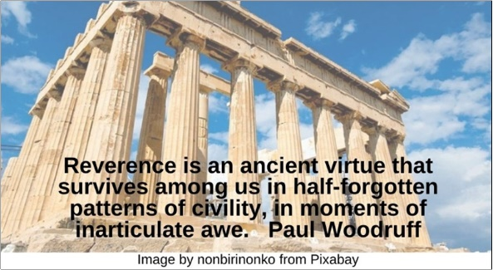

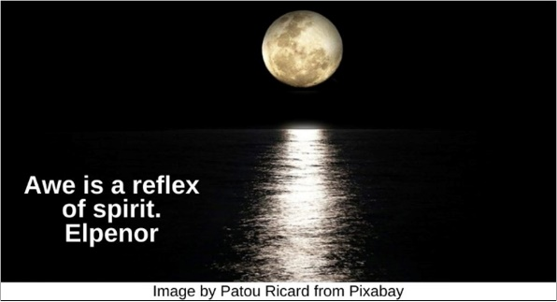



Blessing HRJ
Celtic Imagination HRJ
Compassion HRJ
Contempt HRJ



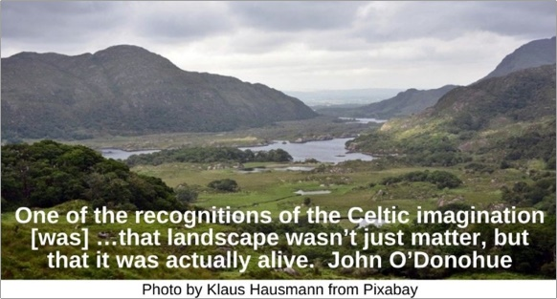

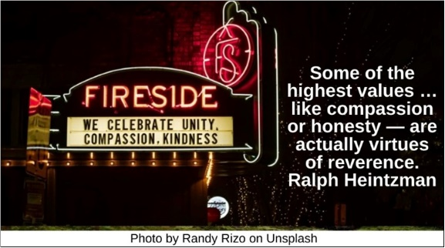



Epiphany HRJ
Exhaustion HRJ
Eye HRJ
Gives HRJ

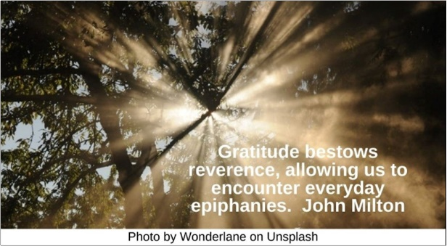

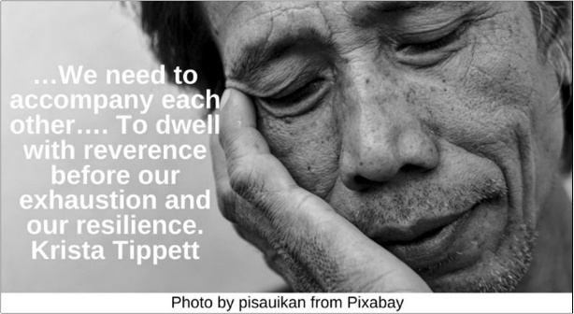



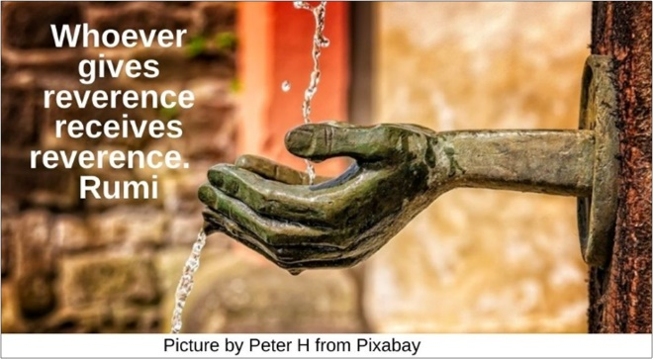

God HRJ
Grand Canyon HRJ
Greater Than HRJ
Humility HRJ

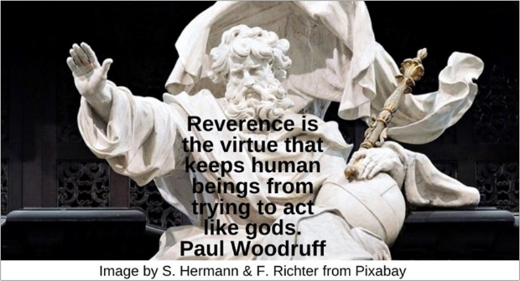

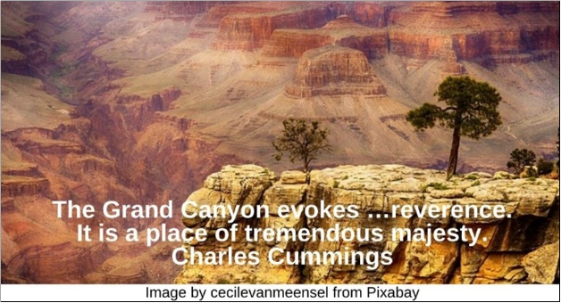

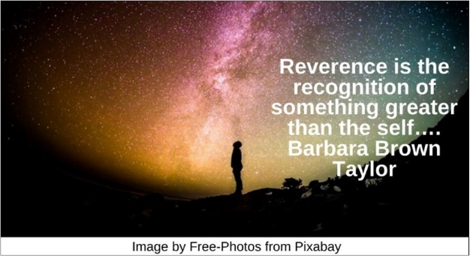



Jasmine HRJ
Love Widened HRJ
Medicine HRJ
Namasté HRJ

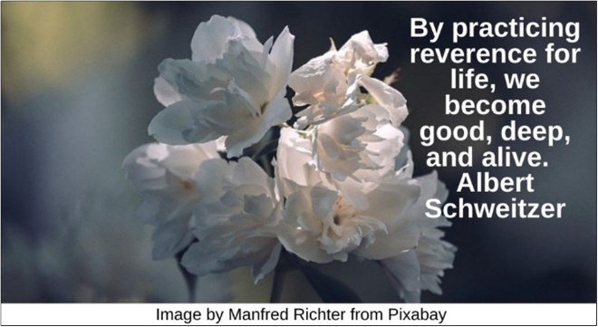





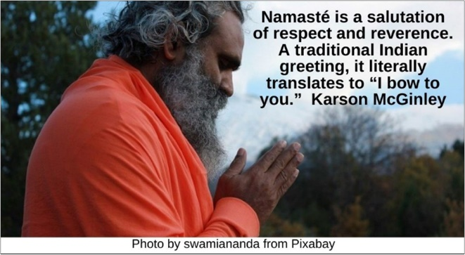

Path HRJ
Profound Love HRJ
Puzzle HRJ
Rainbow HRJ

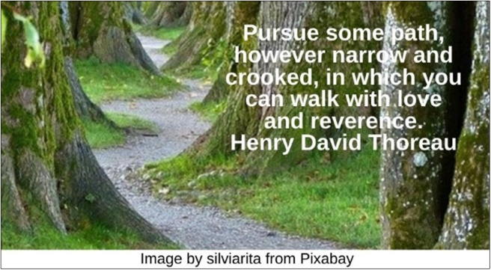

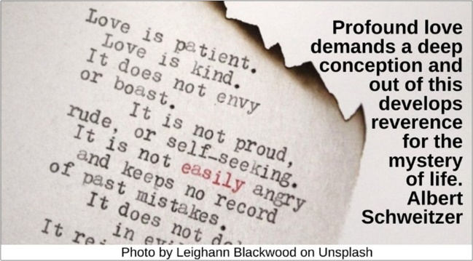

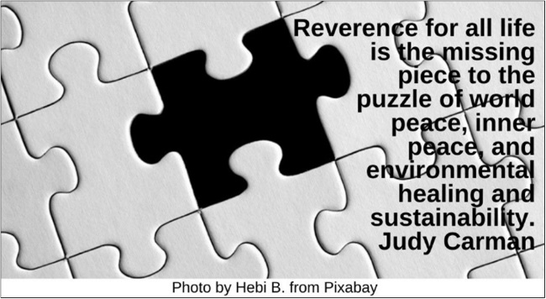

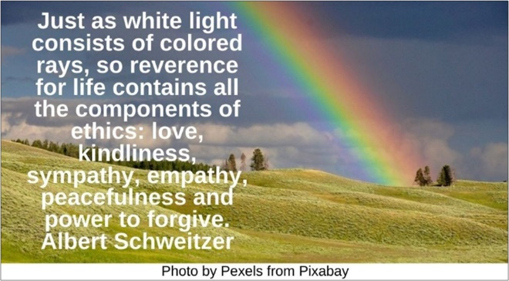

Ritual Acts HRJ
Sacred Place HRJ
Sparrow HRJ
Tree HRJ

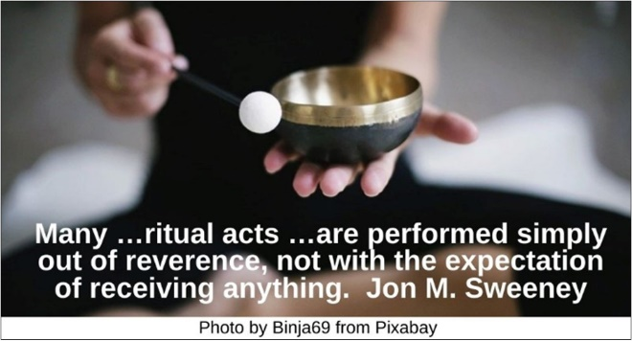





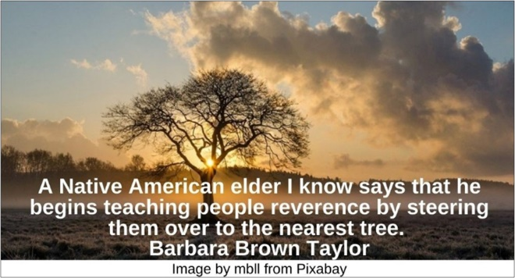

Vastness HRJ
Walk Humbly HRJ
Water HRJ
Zen HRJ



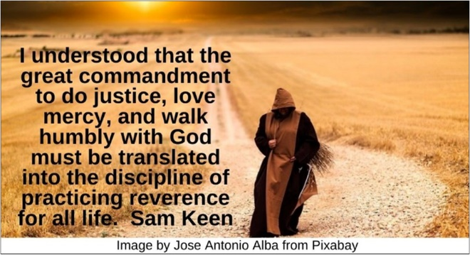



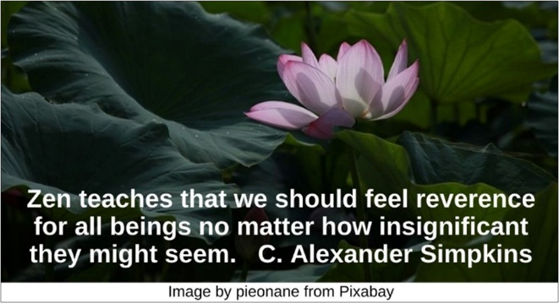

Text of Quotes
Alone HRJ
And life without reverence? …That would be brutish and selfish, and it had best be lived alone.” Paul Woodruff

Ancient Virtue HRJ
Reverence is an ancient virtue that survives among us in half-forgotten patterns of civility, in moments of inarticulate awe. Paul Woodruff

Awe HRJ
Awe is a reflex of spirit. Elpenor

Beyond Tolerance HRJ
Perhaps it's time for us to …move …from tolerance to reverence. Ray Riegert

Blessing HRJ
A blessing is an act of reverence… Roger Housden

Celtic Imagination HRJ
One of the recognitions of the Celtic imagination [was] …that landscape wasn’t just matter, but that it was actually alive. John O’Donohue

Compassion HRJ
Some of the highest values …like compassion or honesty — are actually virtues of reverence. Ralph Heintzman

Contempt HRJ
The words contempt for life …made me think at once of Reverence for Life…. Frederick Franck

Epiphany HRJ
Gratitude bestows reverence, allowing us to encounter everyday epiphanies. John Milton

Exhaustion HRJ
…We need to accompany each other…. To dwell with reverence before our exhaustion and our resilience. Krista Tippett

Eye HRJ
Our capacity for awe is the lens through which creation passes…. Marilynne Robinson

Gives HRJ
Whoever gives reverence receives reverence. Rumi

God HRJ
Reverence is the virtue that keeps human beings from trying to act like gods. Paul Woodruff

Grand Canyon HRJ
The Grand Canyon evokes …reverence. It is a place of tremendous majesty. Charles Cummings

Greater Than HRJ
Reverence is the recognition of something greater than the self…. Barbara Brown Taylor

Humility HRJ
Reverence is a kind of awe, and awe is a kind of humility. Marilynne Robinson

Jasmine HRJ
By practicing reverence for life, we become good, deep, and alive. Albert Schweitzer

Love Widened HRJ
The ethic of Reverence for Life is the ethic of love widened into universality. Albert Schweitzer

Medicine HRJ
Medicine is a spiritual path, which is characterized by compassion, harmlessness, service, reverence for life, courage, and love. Rachel Naomi Remen

Namasté HRJ
Namasté is a salutation of respect and reverence. A traditional Indian greeting, it literally translates to “I bow to you….” Karson McGinley

Path HRJ
Pursue some path, however narrow and crooked, in which you can walk with love and reverence. Henry David Thoreau

Profound Love HRJ
Profound love demands a deep conception and out of this develops reverence for the mystery of life. Albert Schweitzer

Puzzle HRJ
Reverence for all life is the missing piece to the puzzle of world peace, inner peace, and environmental healing and sustainability. Judy Carman

Rainbow HRJ
Just as white light consists of colored rays, so reverence for life contains all the components of ethics: love, kindliness, sympathy, empathy, peacefulness and power to forgive. Albert Schweitzer

Ritual Acts HRJ
Many …ritual acts …are performed simply out of reverence, not with the expectation of receiving anything. Jon M. Sweeney

Sacred Place HRJ
There are no unsacred places. There are only sacred places and desecrated places. Wendell Berry

Sparrow HRJ
…Ultimately there was no distinction among sparrows, sapsuckers, and me. I owed reverence, respect, and restraint to all. Sam Keen

Tree HRJ
A Native American elder I know says that he begins teaching people reverence by steering them over to the nearest tree. Barbara Brown Taylor

Vastness HRJ
When we experience ourselves as one small part of nature, we feel reverence. Annellen Simpkins

Walk Humbly HRJ
I understood that the great commandment to do justice, love mercy, and walk humbly with God must be translated into the discipline of practicing reverence for all life. Sam Keen

Water HRJ
That stream water …had soul for me. Cait Johnson

Zen HRJ
Zen teaches that we should feel reverence for all beings no matter how insignificant they might seem. C. Alexander Simpkins

